

Project Fun2
Default UNLI

Detailed Functional Specifications (DFS)

Prepared By: | Recommended By: | Approved By:
Guilbert M. Lenon  Yiucon Unlimited Concepts | Daryll Diaz  ISG SD ITSI | ISG SD ITSI
SIGNATURE:  DATE: | SIGNATURE:  DATE: | SIGNATURE:  DATE:

Revision History

Ver No. | Date of Release | Prepared By | Reviewed/Approved By | List of Changes from Previous Version
1.00.00 | 09/24/12 | Guilberto Lenon |  | Initial Draft

Contents

1.0 Introduction 5
A. Purpose of Document 5
B. Scope of Document 5
C. Technical Contact 5
2.0 System Overview 5
A. System Architecture 6
B. Transaction Flow 6
C. System Interfaces 7
D. BUR 7
E. System Functionalities 8
3.0 Database Structure 12
A. Table Schema 12
1. default_unli_log 12
2. broadcast_log 13
3. roaming_partners 13
4. mcc_messages 13
5. radcom_downloaded_files 14

Introduction

Purpose of Document
This document is intended to outline the technical and functional specifications of Project Fun2 Default UNLI service that will utilize the broadcaster module of FUN2 to notify postpaid roaming subscribers upon their first data usage. It details the components, network connections as well as hardware and software dependencies. This document is intended for technical people who have a background on networking, database and Unix/Linux.

Scope of Document
This document will outline the following information:
- System Architecture
- Transaction Flow
- System Interfaces
- System Functionalities

Technical Contact
Alexander Magtipon – Solution Architect, Yiucon Unlimited Concepts Inc. (zand3rs@gmail.com)
Guilbert Lenon – Project Manager, Yiucon Unlimited Concepts, Inc. (guilbert.lenon@yiucon.com)

System Overview

System Architecture
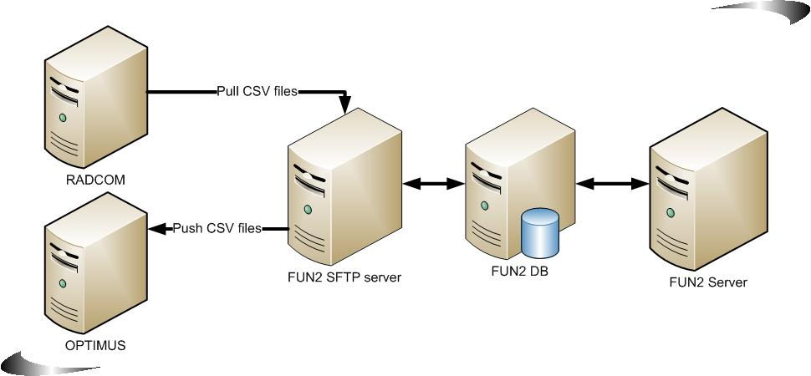

Transaction Flow
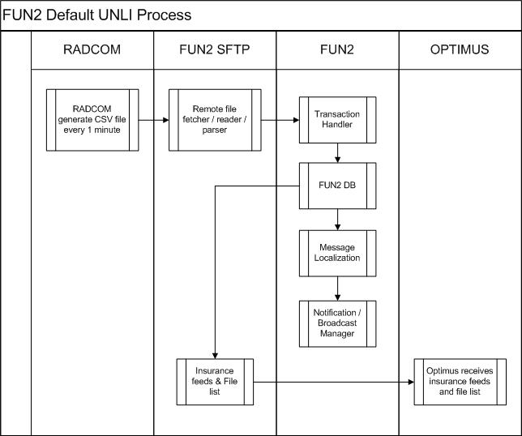

System Interfaces

- Communication Protocol
The application interface would be via SFTP
- Connection Details
Fun2 will pull CSV file from RAVEN directory under RADCOM via SFTP (server that generates reports that contains roaming usage details of postpaid subscriber) for every 1 minute.
- Path to Raven CSV files: /radcom/omniq/csv/Export_Raven
- Raven csv files from radcom should be in the following file name format:
{fileCreationTime:yyyyMMdd_hhmmss}freeuserchars{filename} freeuserchars{autoincrement}.csv
For example
- 2013_11_20_07_27_Gi_pid29662_ins1_thread_0_1943.csv

Fun2 needs to create a logic that will be able to determine if the CSV file is already pulled. Otherwise, the file will be duplicated and it should be rejected.

File list should be also being provided containing the files sent for the day and relevant checksum for audit and file handling.
File Error Handling:
  - FUN2 will only read files from RADCOM server with the agreed working directory.
  - FUN2 will not process files that are not compliant to agreed file naming convention. See file naming convention above.
  - Date and Time Format and the Gi must be in the File name for us to prevent CR. This will be implement in the development

BUR
ID | Function | Functional Requirements | Requirement / Description | Purpose | Requesting Group | DFS  Reference No. | Mandatory | Priority | Remarks
BUR-08 | Sub Experience | Sub Experience | Subscriber not on Default Unli should receive an SMS notification advising the regular rates and recommending subscriber to switch back to specific RP’s that is part of the offer. | Value add to inform subs of the corresponding rate for usage on RPs not part of Default Unli and to offer Default rate | Brand | Item No.9  Page 9  Item No. 11  Page 10 | Yes | High
BUR-09 | Sub Experience | Sub Experience | Subscriber should receive SMS Notification upon start of Data use | Value add to allow subs to track data roaming spend | Brand | Item No. 6  Page 9 | Yes | High
Added | Sub Experience | Sub Experience | Subscriber should receive SMS pre-expiry notification 3 hours before the actual expiry time |  | Brand | Item No. 7  Page 9 | Yes | High
ADDED | Sub Experience | Sub Experience | Subscriber should receive SMS expiry notification on the 24th hour upon start of data usage |  | Brand | Item No. 8  Page 9 | Yes | High
BUR-21 | Report | Report | Daily report on unique subscribers availing of the offer – as reference for travel insurance offer and claim |  | Brand | Item No. 10  Page 9 | Yes | High | CSV file containing list of subscribers availed default unli under identified RP will be sent to Optimus  for daily and monthly report for insurance availment, under FUN2
ADDED | Report | Report | File List should be sent to Optimus |  | Brand | Item No. 10  Page 10 | Yes | High
BUR-22 | Report | Report | Monthly report on unique subscribers availing of the offer – as reference for travel insurance settlement |  | Brand | Item No. 10 Page 9 | Yes | High | input for this will be the same as BUR-21  - As per Tin, Monthly report will no longer needed. Optimus will generate Monthly report

System Functionalities

- Fun2 to process the CSV file pulled to get the following details
- Mobile Number
- Date and Time of Transaction(start date and time of transaction in UTC +0 format for outbound roamers)
- Mobile Network Code (MNC)
- Mobile Country Code (MCC)
- SGSN - IP
- Notified Flag (BOOLEAN) - Optional

  - Transaction Error Handling:
    - All information (Mobile number, Date and Time, MNC, MCC, SGSN – IP) should be available non-compliance will tag record as invalid.
    - MCC should have a corresponding mapping on mcc_messages, no mapping on mcc_messages will tag record as invalid.

    - Mobile number should be 12 digits and 63xxxxxxxxxx format, non-compliance will tag record as invalid.

    - Date and Time of transaction should be in valid form, non-compliance will tag record as invalid.

- FUN2 will create Time zone Field –Timezone for each roaming network partners are reflected on roaming_partner table under column TZ. Please check roaming_partner table on page 14 under Database Structure. kindly reflect the time zone of each selected roaming partners here in the dfs

Country | TZ
Australia | +5
China | +8
Czech Republic | +1
Germany | +1
Hong Kong | +8
India | +5.5
Indonesia | +8
Ireland | +8
Macau | +8
Malaysia | +0
Saudi Arabia | +3
Singapore | +8
South Korea | +9
Spain | +1
Taiwan | +8
Thailand | +7
UK | +0
USA | -8
Vietnam | +7

- FUN2 will no longer need to housekeep or back up files pulled from Radcom, but it needs to have like an audit trail table as a reference. The system will store information for all downloaded files on table radcom_downloaded_files, contains file_name, number of valid records, number of invalid records, and date time it was downloaded. Please check table radcom_downloaded_files on page 14 under Database Structure.
[GL] – Total number of valid and invalid records will be logs for audit trail purposes – kindly reflect it on the DFS

- Add end datetime field on the notification table. Globe optimus no longer requires an end time on the csv files to be sent for the insurance feed.

- Fun2 needs to create a logic that will store subscribers in the new table during their first data usage. Duplicate records will be ignored unless there is a change in the country and network code.
- Validation/filtering will be based on MCC and MNC.
- Fun2 to determine if MNC and MCC is part of selected or regular roaming partner to trigger notifications format.

- Fun2 will trigger activation notification upon start of data usage. Please see SMS Notification Format.xslx for the sample notification
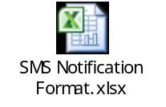

- Fun2 will trigger dynamic pre-expiry notification 3 hours before the actual expiry time. Please see SMS Notification Format.xslx for the sample notification

- Fun2 will trigger dynamic expiry notification on the 24th hour upon start of data usage

- Fun2 will trigger notifications for every change of locations (country or roaming partner). Please see SMS Notification Format.xslx for the sample notification
*Note - subscribers will receive multiple notifications for every event of change of network/country.

- Fun 2 will generate a CSV file by the end of day (11:59PM) containing records of first time usage of MSISDNs with MNC of selected partners and to be pushed to Optimus as basis for insurance feed for default unli subs.
- Insurance feed should be in the following file name format:
FUN2_EXT.<extract date YYYYMMDD>.<time in HH24MISS>.<Record Count>.txt
Sample Value: FUN2_EXT.20130529.202800.1050.txt

- The following fields are to be sent to Optimus:
Kindly provide tables schema/data types for following field.
We will not create a table for these, we will generate a file containing all the subscribers with first usage.
[NES] – what we are trying to say is kindly reflect the data types of the fields below that are going to send to optimus(please see refer below for the following data types).

[TIN] - Noted on this sir. Expectation here is, format for below fields is already based on Optimus’ requirement, kindly confirm sir.

- MSISDN
- START DATE and TIME
- MNC
- MCC

- Please refer below for the following data types). Please confirm if these are the data types that Fun2 will push to optimus.
- [UCON] – Yes data for optimus will be provided in a data format below.

Field name | Data format
MSISDN | VARCHAR12
MNC | VARCHAR10
MCC | VARCHAR10
Start date time | MM/DD/YYYY HH:MM:SS

- Generated files will be stored on /appl/fun2/log/optimus

Start/End datetime format should be in YYYYMMDDHH24MISS.

File list Specification
Filename format & Data format:
File Format: <source system>.<source file type>.filelist.<extract date YYYYMMDDHH24MISS>.done
Sample: CSP.CSPTXN2.filelist.20130521011517.done

Data Format:
00<tab><extract timestamp in YYYYMMDDHH24MISS>
01<tab><data file name><tab><checksum>
01<tab><data file name><tab><checksum>
…
99<tab><Number of files>
Sample:
00 20130521011517
01 CSP.CSPTXN2.20130521.011517.2425234.txt.gz 1233423423
99 1

- Fun2 needs to create a logic that will inform/notify subscriber once change location that the RP (Roaming Partner) they are connected has no default unli service. All data subscription will be chargeable. On the other hand, FUN2 should also inform them to switch back to previous RP (Roaming Partner). Please see SMS Notification

- Message to broadcast for subs with first time usage or with switch network advisory will be based on the ff criteria: (Needs to be detailed)
    - Check data of MNC column from default_unli_log table
    - Verify if data from MNC column is a partner network, it should have a match from MNC column of roaming_partners table.
default_unli_log.mnc = roaming_partners.mcc
    - If there is no matching mnc on roaming_partners table, send switch network advisory
      - To send switch network advisory, verify data from MCC column of default_unli_log table and find a match on MCC column of table mcc_messages.
default_unli_log.mcc = mcc_messages.mcc
      - If there is no matching mcc data on mcc_messages, log record as Invalid MCC on /appl/fun2/log/fun2_default_unli.log.
      - If there is matching mcc on mcc_messages, send switch network advisory by inserting record on broadcast_log table. broadcast_log table can be found on Page 13.
    - If there is a matching mnc on roaming_partners table, send first time usage notification
      - To send switch first time usage notification, verify if data from MCC column of default_unli_log table has a match on MCC column of table mcc_messages.
default_unli_log.mcc = mcc_messages.mcc
      - If there is no matching mcc on mcc_messages, log record as Invalid MCC on /appl/fun2/log/fun2_default_unli.log.
      - If there is matching mcc on mcc_messages, send first time usage notification by inserting record on broadcast_log table. broadcast_log table can be found on Page 13.

- Error Handling
  - all errors are to be in logs files
    - please notify radcom if encounter error, notification should be manually done, done by monitoring team.
  - Logs files are real-time
    - Yes, log files are real-time
  - Please provide Logs Directory
    - /appl/fun2/log/fun2_default_unli.log

Database Structure

Table Schema
For static tables system admin can add/edit/delete the values. The static tables are roaming_partners and mcc_messages.

default_unli_log
– Please provide sample values
[TIN] - Noted on this sir. Thank you. But can we add it in the table sir? By inserting another column in the table? Instead of screenshot? Thank you sir
Name | Null | Type | Description | Sample Data
ID | NOT NULL | NUMBER(11) | Sequence No. | 1
MSISDN | NOT NULL | VARCHAR2(30) | Mobile Number | 639171231212
tran_dt | NOT NULL | date | Transaction Date | 01-Feb-14 00:00:00
tran_tm | NOT NULL | date | Transaction Date & Time | 01-Feb-14 12:09:57
Mnc | NOT NULL | VARCHAR2(30) | Mobile Network Code | 515
mcc | NOT NULL | VARCHAR2(30) | Mobile Country Code | 2
SGSN_IP | NOT NULL | VARCHAR2(30) | SGS IP | 202.89.204.14
status | NOT NULL | NUMBER(1) | Status | 0
Expiry_date | NOT NULL | DATE | Expiry date | 02-Feb-14 12:09:57
DT_CREATED | NOT NULL | DATE | Date inserted | 01-Feb-14 12:09:57
FILE_NAME | NOT NULL | VARCHAR2(60) | File reference | 2013_12_11_17_  43_Gn_pid28534_  ins1_thread_5_1.csv

“ERR_MESSAGE” field in default_unli_log table should be remove since it will place into a log file

broadcast_log
– Please provide sample values
Name | Null | Type | Description | Sample Data
ID | NOT NULL | NUMBER | Sequence No. | 1
MSISDN | NOT NULL | VARCHAR2(30) | Mobile Number | 639171231212
MESSAGE_ID |  | VARCHAR2(60) | Message ID | 1
TX_DATE | NOT NULL | DATE | Transaction Date | 01-Feb-14 12:09:57
STATUS | NOT NULL | NUMBER(1) | Status | 0
CLUSTER_NODE | NOT NULL | NUMBER(3) | Cluster Node | 1
MSG |  | VARCHAR2(2000) | Message | Thank you for using Roam UnliSurf! You can now enjoy 24 hrs of unlimited surfing at only P599, with FREE TravelCare insurance for up to 30 days. Please manually select Optus during your stay, as usage on other networks is charged at P300/MB. For TravelCare info, dial *143# toll-free.

roaming_partners
– Please provide sample values
Name | Null | Type | Description | Sample Data
ID | NOT NULL | NUMBER | Sequence No. | 1
mnc | NOT NULL | VARCHAR2(30) | Mobile Network Code | 515
mcc | NOT NULL | VARCHAR2(60) | Mobile Country Code | 2
tz | NOT NULL | VARCHAR2(30) | Timezone | +8
DT_CREATED | NOT NULL | DATE | Date inserted | 01-Feb-14 12:09:57

mcc_messages
– Please provide sample values
Name | Null | Type | Description | Sample Data
ID | NOT NULL | NUMBER | Sequence No. | 1
mcc | NOT NULL | VARCHAR2(60) | Mobile Country Code | 2
message_type | NOT NULL | VARCHAR2(30) | Message Type | 1
message | NOT NULL | VARCHAR2(2000) | Message | Thank you for using Roam UnliSurf! You can now enjoy 24 hrs of unlimited surfing at only P599, with FREE TravelCare insurance for up to 30 days. Please manually select Optus during your stay, as usage on other networks is charged at P300/MB. For TravelCare info, dial *143# toll-free.
DT_CREATED | NOT NULL | DATE | Date inserted | 01-Feb-14 12:09:57

radcom_downloaded_files
– Please provide sample values
Name | Null | Type | Description | Sample Data
ID | NOT NULL | NUMBER | Sequence No. | 1
file_name | NOT NULL | VARCHAR2(60) | File name | 2013_12_11_17_  43_Gn_pid28534_  ins1_thread_5_1.csv
NO_Valid | NOT NULL | NUMBER | Number of valid records | 7152
NO_ERRORS | NOT NULL | NUMBER | Number of invalid records | 1028
DT_UPLOADED | NOT NULL | DATE | Date uploaded | 01-Feb-14 12:09:57

